Assignment for Module 10
The assignment for Module 10 involves problems for schema conversion. Problems 1 to 4 involve the ERD in Figure 1.
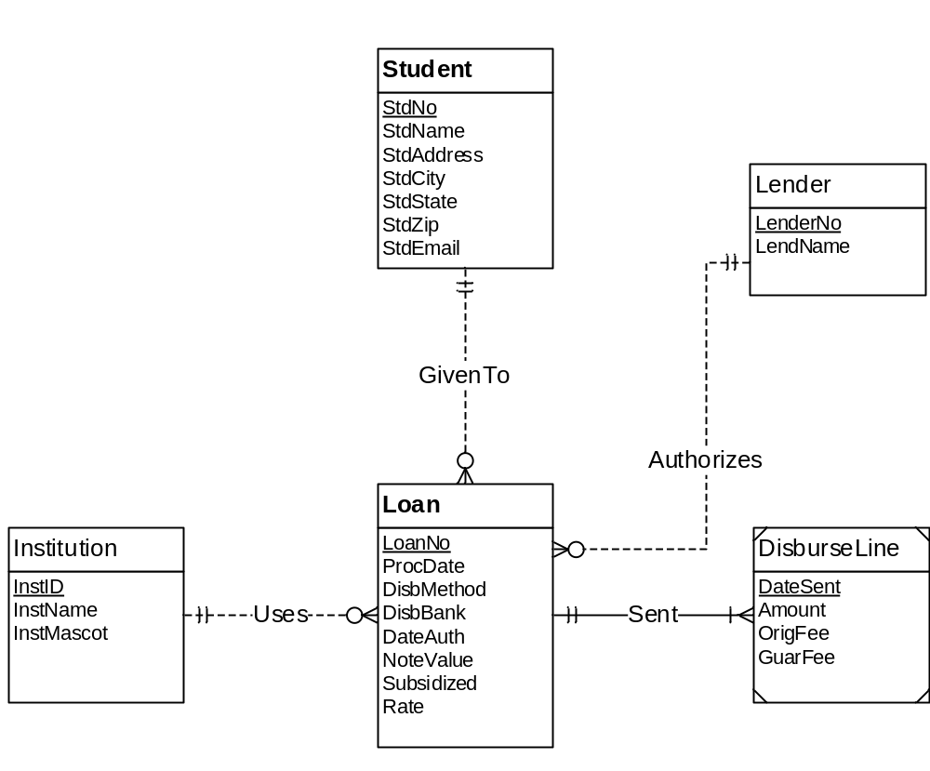
Figure 1: ERD for Problems 1 to 4

1. Requirements for Data Modeling Problems

- For the ERD in Figure 1, you should indicate the applications of the entity type rule. For each entity type rule application, you should identify the table name, primary key, and other columns. You do not need to write CREATE TABLE statements.
Solution:
Entity Type Rule is applicable to the entity types Student,Lender,Institution,Loan,DisburseLine.
Student(StdNo ,StdName,StdAddress,StdCity,StdState,StdZip,StdEmail)
Lender(LenderNo,LendName)
Loan(LoanNo,ProcDate,DisbMethod,DisbBank,DateAuth,NoteValue,Subsidized,Rate)
Institution(InstID,InstName,InstMascot)
DisburseLine(DateSent,Amount,OrigFee,GuarFee)

- For the ERD in Figure 1, you should indicate applications of the 1-M relationship rule. For each 1-M relationship rule application, you should indicate the changes to the tables you listed in problem 1 including foreign key columns and NOT NULL constraints for foreign keys if necessary.
Solution:
1-M Relationship Rule is applicable to Loan Entity Type
So,Loan Entity Type schema changes to
Loan(LoanNo,ProcDate,DisbMethod,DisbBank,DateAuth,NoteValue,Subsidized,Rate,StdNo,LenderNo,InstID,FOREIGN KEY(StdNo) REFERENCES Employee , FOREIGN KEY(LenderNo) REFERENCES Lender, FOREIGN KEY(InstID) REFERENCES Institution , StdNo NOT NULL,LenderNo NOT NULL,InstID NOT NULL)

- For the ERD in Figure 1, you should indicate applications of the M-N relationship rule. For each M-N relationship rule application, you should list the table name, primary key, and other columns.
Solution : There are no M-N Relationships in the given ERD.

- For the ERD in Figure 1, you should indicate applications of the identifying relationship rule. For each identifying relationship rule application, you should indicate the changes to the tables you listed in problem 1.
Solution :
Identifying Relationship Rule is applicable to DisburseLine Entity Type.
So,DisburseLine entity’s schema changes to
DisburseLine(DateSent,Amount,OrigFee,GuarFee,LoanNo,FOREIGN KEY(LoanNo) REFERENCES Loan ,LoanNo NOT NULL)

- Convert the ERD shown in Figure 2 into tables. List the conversion rules used and table design. For each table, you should list the primary key, foreign keys, other columns, and NOT NULL constraints for foreign keys if necessary. You do not need to write CREATE TABLE statements.
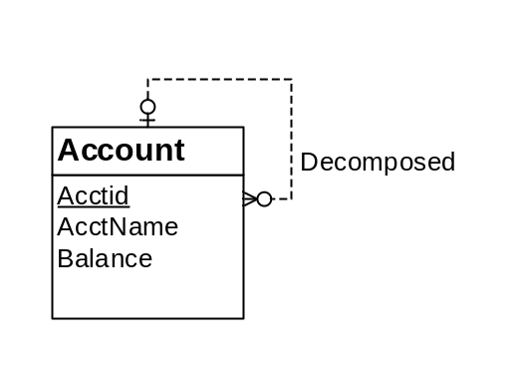
Figure 2: ERD for Conversion Problem 5

Solution :
Account(Acctid,AcctName,Balance,DecompositionID,FOREIGN KEY (DecompositionID)
REFERENCES Account,DecompostionID NOT NULL)
Conversion Rules:
Entity Type Rule for the Entity Type Account.
1-M Relationship Rule for the Decomposed Relationship.

- Convert the ERD shown in Figure 3 into tables. List the conversion rules used and table design. For each table, you should list the primary key, foreign keys, other columns, and NOT NULL constraints for foreign keys if necessary. You do not need to write CREATE TABLE statements.
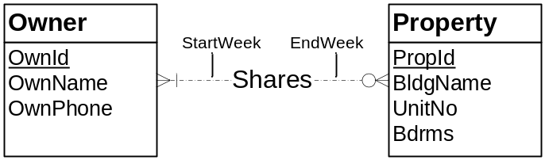
Figure 3: ERD for Conversion Problem 6
Solution:
Owner(OwnId,OwnName,OwnPhone)
Property(PropId,BidgName,UnitNo,Bdrms)
Shares(OwnId,PropID,StartWeek,EndWeek,
FOREIGN KEY(OwnId) REFERENCES Owner,
FOREIGN KEY(PropID) REFERENCES Property,
OwnId NOT NULL)
Conversion rules
Use the entity type rule to convert each entity type
Use the 1-M relationship rule for all relationships except the shares relationship
Use the M-N rule to convert the shares relationship

